Docker question 1

1. Created a Dockerfile

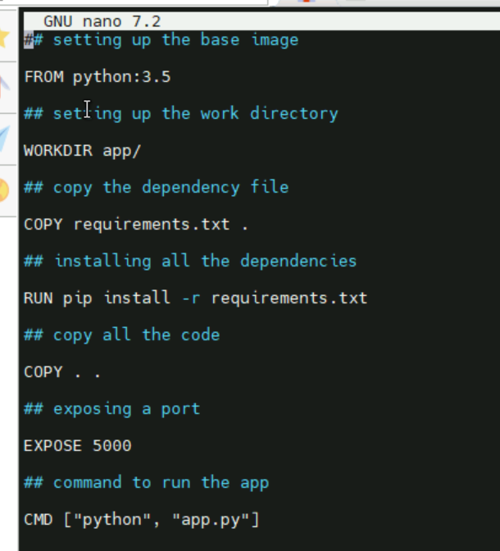

1. builded image : docker build -t abhiramikannan/python-image
2. created a container named flask-container

docker run -d -p 5000:5000 –name flask-container abhiramikannan/python-image

1. get inside the container using exec command

docker exec -it flask-container pwd

1. by pwd got the working directory inside the container

docker exec -it flask-container pwd

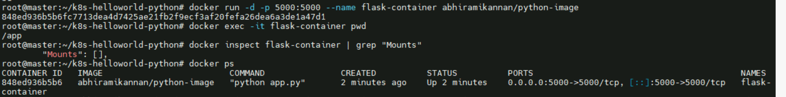

1. the read write-layer directory on the host

docker inspect –format ‘{{.GraphDriver.Data.MergedDir}}’ flask-container

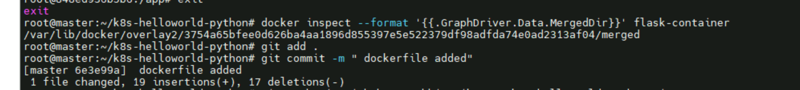

1. pushed the image into docker hub

docker push abhiramikannan/python-image

